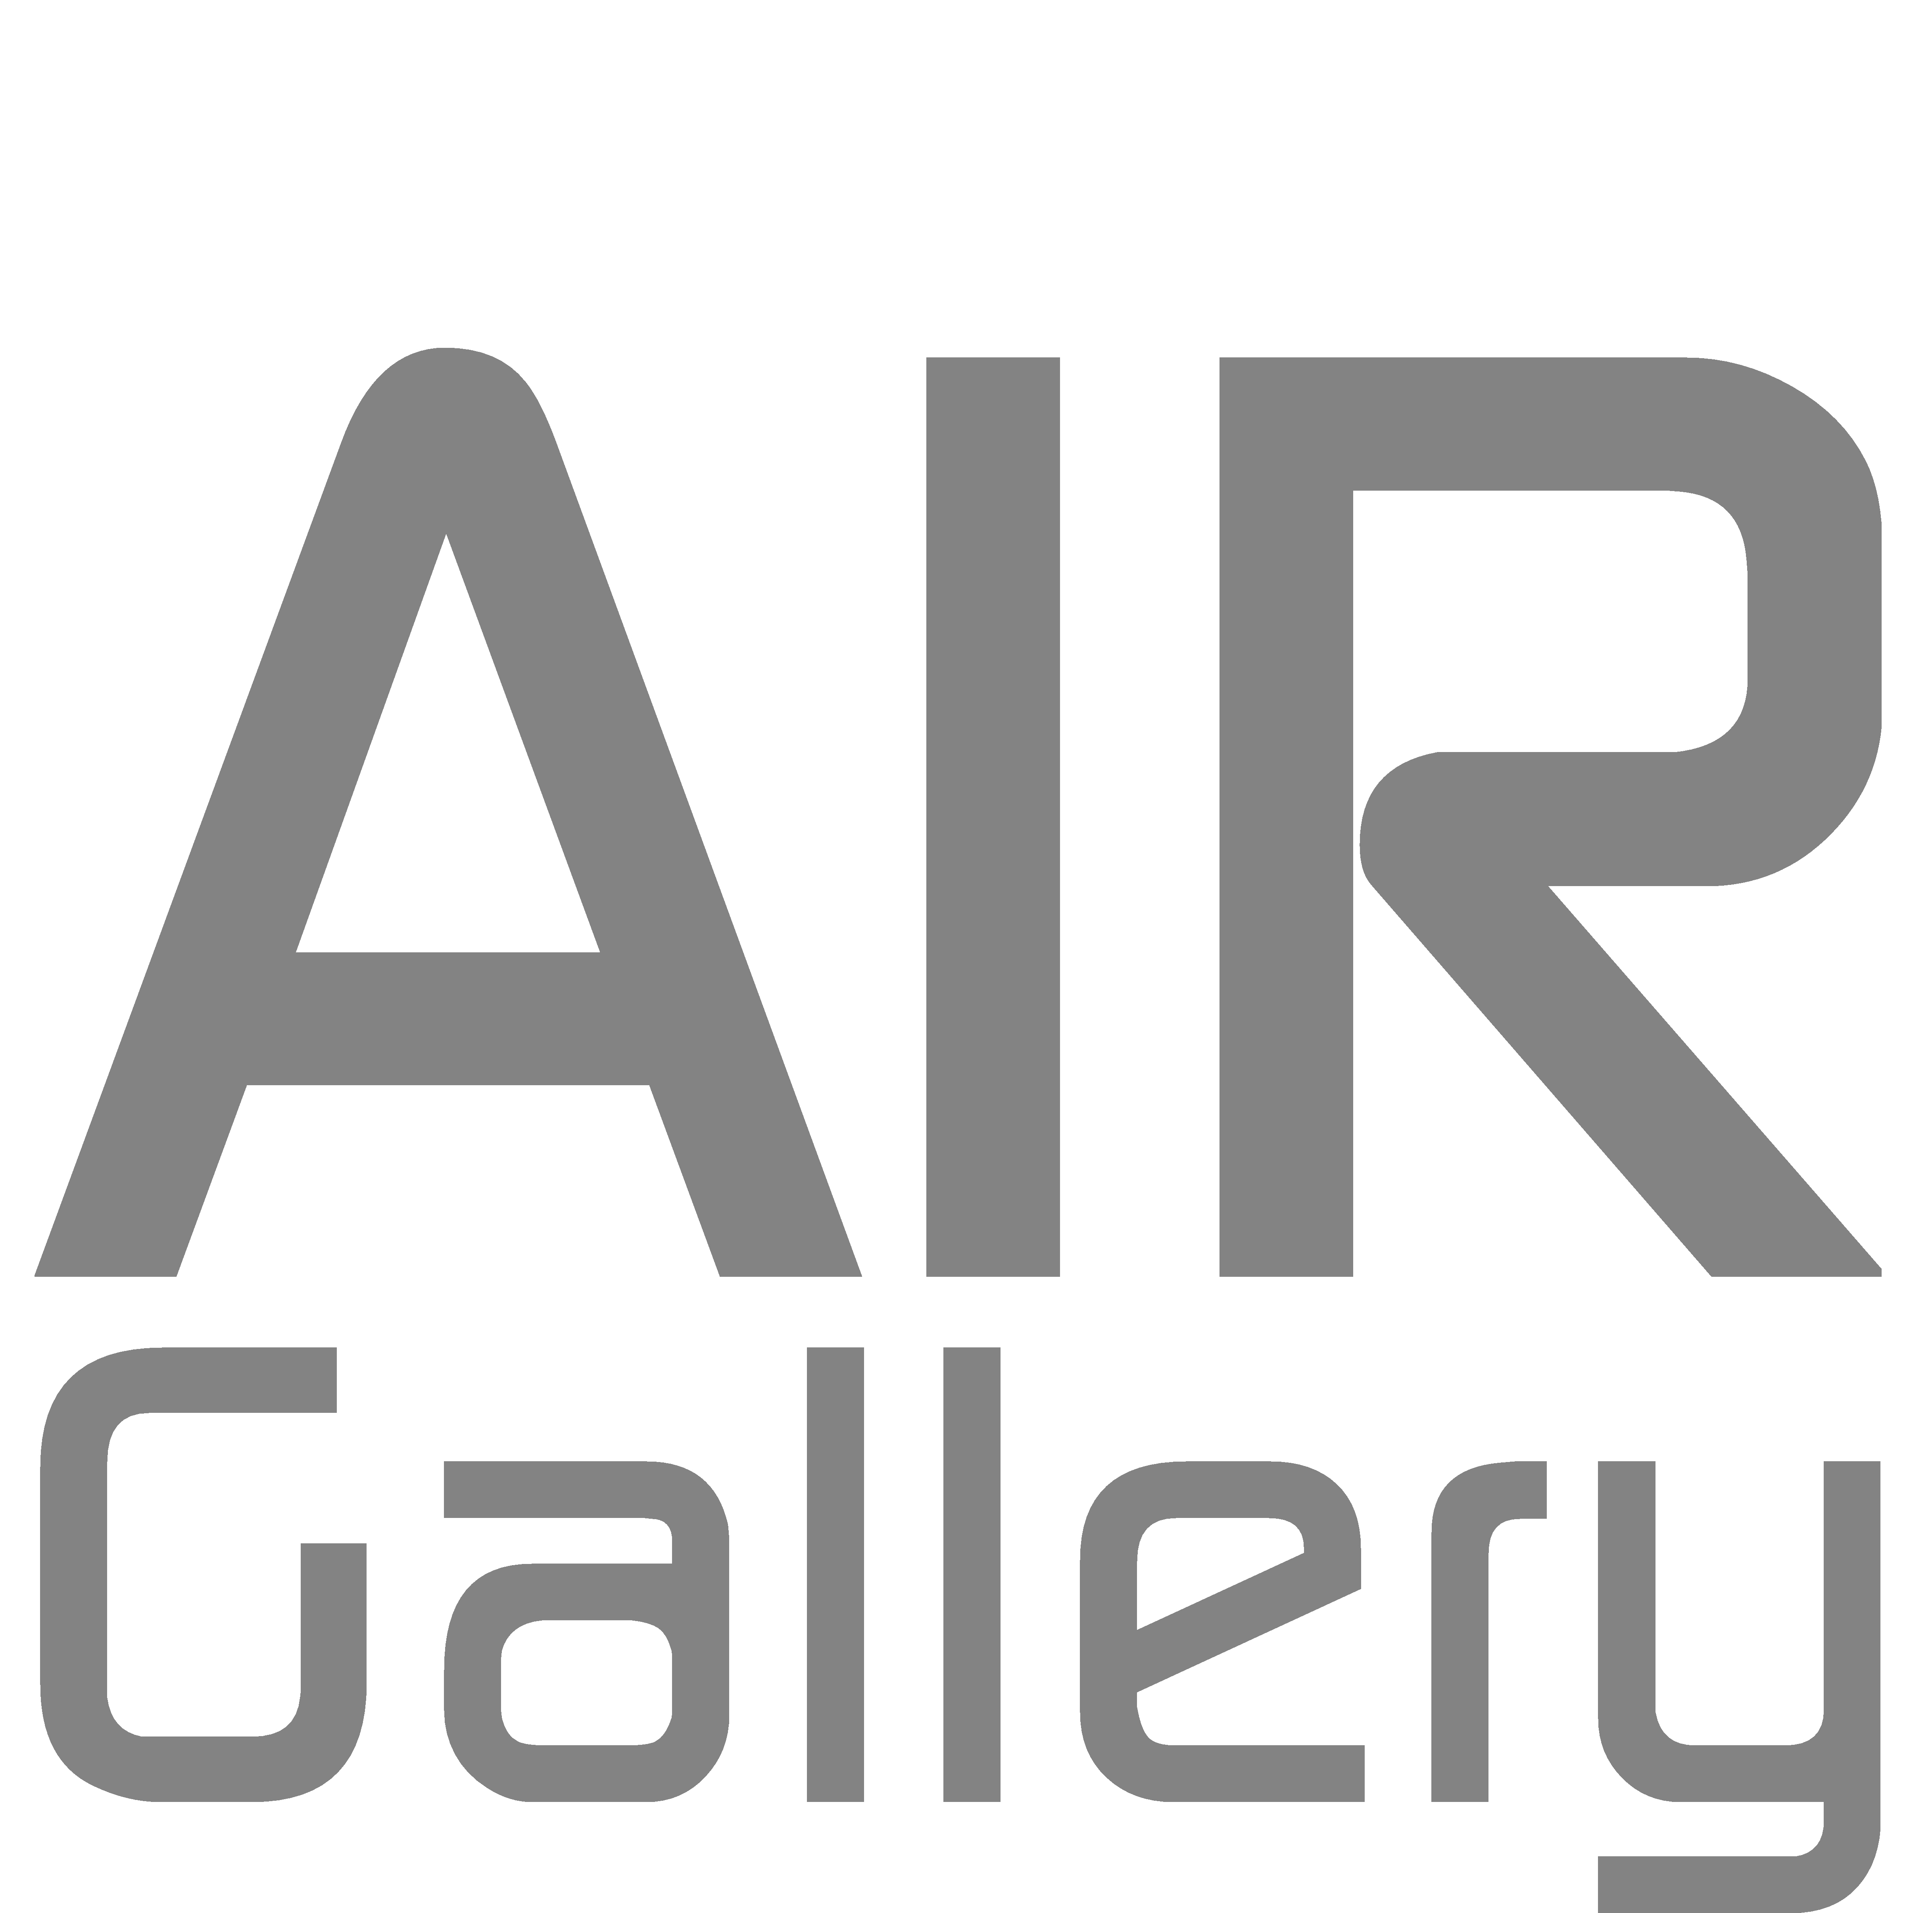
AIR Gallery
Warehouse, 30 Grosvenor Road
Altrincham, WA14 1LD
0161
info.airgallery@gmail.com
www.a4studios.co.uk

(Please read our Terms and Conditions before completing this form)

Platform
Bursary Award Application Form

Contact Details

Name
Address
Contact Number
Email

Will you require any additional support or access needs?

If yes then please specify your support needs

Artist Details
We would like to know a little about you and the type of work that you current do.

Statement about you and your creative background
(No more than 250 words)

Artist Website

Statement about your current practice
(No more than 250 words)

The Bursary
Our bursary is intended to help emerging and early career artists carrying out a project or body of work that they have been unable to do so previously due to lack of funds.

Please specify below the project or body of work you would like to apply to the scheme for. (Continue on a seperate page if necessary)

How would the bursary enable you to carry out the work above?
As part of our bursary scheme we do require all artists to adhere to our terms and conditions. Please complete the checklist below to confirm that you agree to the conditions set.

Conditions
- Selected artist(s) are require to attend the bi-monthly meetings on the dates agreed.
- Selected artist(s) are required to keep an up-to-date budget list of their expenditure on the project and provide this when requested, with receipts.
- Selected artist(s) are required to keep to the timeframes given
- Selected artist(s) are not allowed to fund a project other than the one specified. We do allow small deviations if there is a clear link to the original submission or the artists can show the progress from one to the other.
- Selected artist(s) will agree to run an event during the exhibition to encourage visitor engagement. Eg: talk, workshop, tour, Q&A etc.
- Selected artist(s) are required to complete an end of project report with their gallery mentor.

If you have a specific idea for the visitor engagement event, please list it here:

I agree to the Terms and Conditions.

Signature
Date

Please send your complete application along with a selection of your previous works to info.airgallery@gmail.com by midnight on Sunday 1st April.

Applications can also be completed by hand and sent by post to AIR Gallery, 30 Grosvenor Road, Altrincham, WA14 1LD.

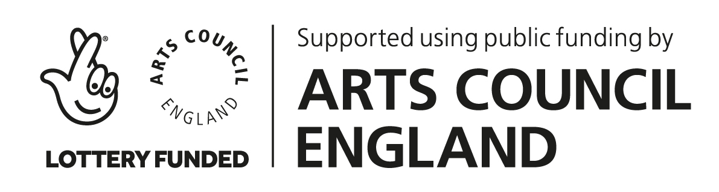
AIR Gallery will ensure that any personal information provided by you on this Bursary Application Form will be treated in accordance with the provisions of the Data Protection Act 1998.AIR Gallery is the Data Controller of the information you have provided on this form.

